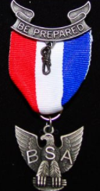
Eagle Scout Press Release:
Name of Eagle Scout:
Date of Eagle Court of Honor:
Name of Parents:
Resident of which City:
Troop Number and sponsoring organization:
School & Grade:
Interests:
Leadership, Service, sports, clubs:

Life Plans:

Eagle Project & Description:

INSTRUCTIONS
- Enter the above information into a WORD document (so it can be copied into a news release)
- Photo: Send jpeg photo of the Eagle Scout in Uniform, include name of photographer and that permission is granted to have the photo published.
- Send the Word Document and photo to: Ken Mano, kenmano@comcast.net
- A news release with the above information will be submitted to the local Tri-Valley newspapers (there is no guarantee that it will actually be published, but they normally do).
- Please complete & submit this information, it is important for Scouting in our area to receive publicity about the accomplishments of our scouts.
- Rev. Date Mar 7, 2018

